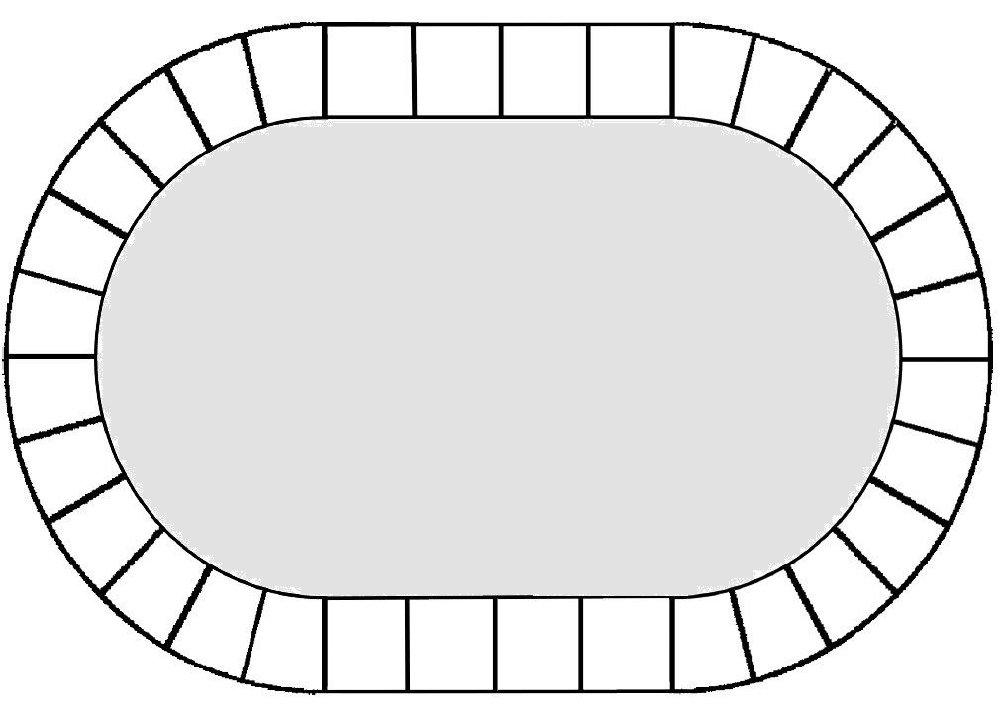

A

A

A

A

A

A

A

A

A

A

A

A

A

A

A

A

A

A





**A**



A

A

A

A

A

A

**A**

**A**

**A**

**A**

**A**

**A**

**A**

**A**

**A**

**A**

**A**

**A**

**A**

**A**

**A**

**A**

**A**

**A**

**A**

**A**

**A**

**A**

**A**

**A**

**A**

**A**





Cartes lettres

|  |  |  |  |  |  |  |  |  |
| --- | --- | --- | --- | --- | --- | --- | --- | --- |
| M  A | A | M | A | N | P | A | P | A |

|  |  |  |  |  |  |  |  |  |
| --- | --- | --- | --- | --- | --- | --- | --- | --- |
| B  A | C | D | E | F | G | H | I | J |